Attendance Reporting Guide

Important Note:
Faculty must log attendance in Attendance Tracking throughout the semester. This centralized system will assist with: Last Date of Attendance (LDA) for Veteran students, Hardship Withdrawal case reviews, Student conduct meetings, and Student success data analysis.

Step-by-Step Directions
- Log in to my.dtcc.edu to access the Student Information System. A link to the Student Information System can be found on the left menu and under General Apps.
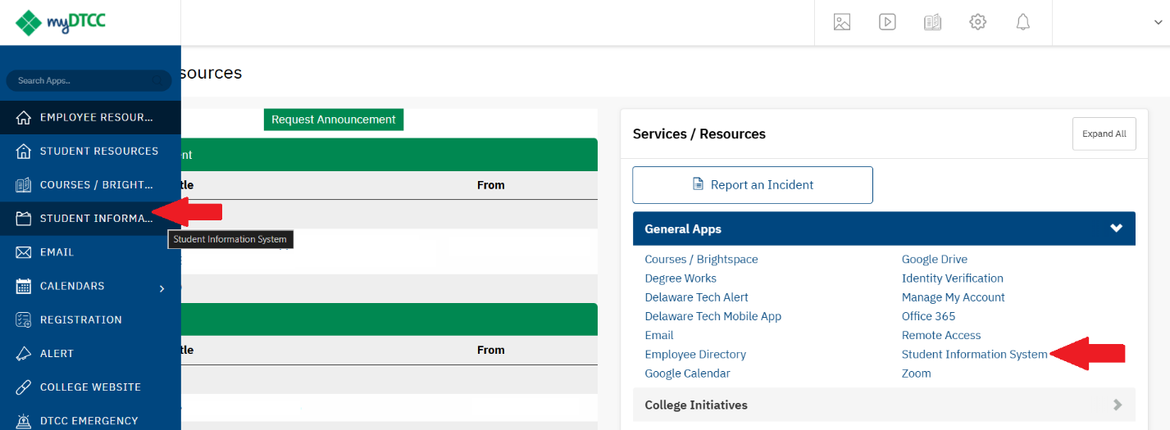

- Under Class Maintenance, select Attendance Reporting.
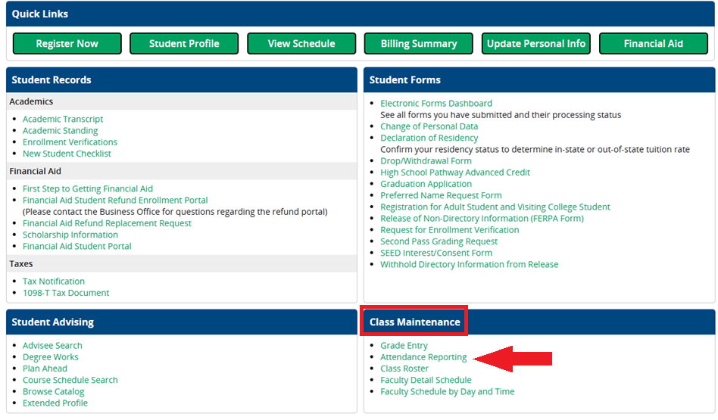
- Locate the course you want to record attendance for.
- Select Take Roll
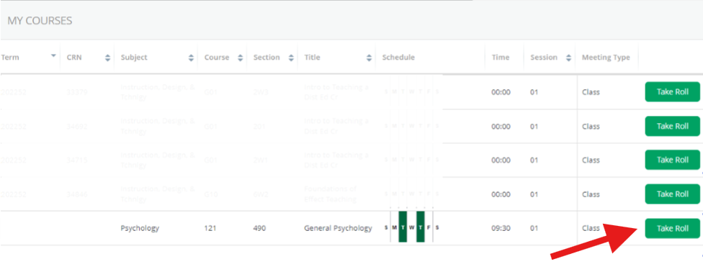
- Open the Calendar Menu
- Choose the date your class meets
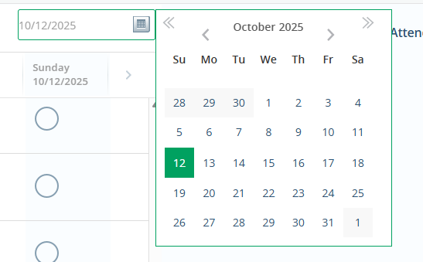
Tip for Online Classes: Select a date after an assignment is completed each week. Keep the date consistent. For example, if your weekly assignments are due on Sundays, choose Monday as the attendance date each week.
- Mark Attendance:
- Present: Click the radio button once (green checkmark appears).
- Absent: Click the radio button twice (red minus symbol appears).
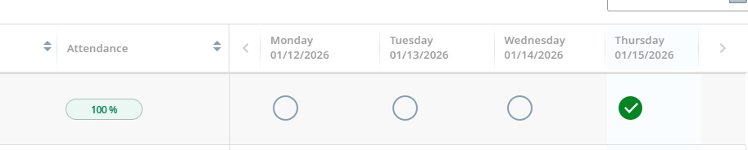

Tip: If a class meets multiple times per week, record attendance for each session separately. For example, if a student attends one session but misses the other, mark them present for the day they attended and absent for the day they missed. Reference the guidance from Attendance Reporting to determine what counts as attendance.
Why This Matters: The system tracks attendance by individual dates to provide an accurate record for reporting purposes (e.g., Last Date of Attendance, hardship considerations). Correctly marking attendance will not trigger withdrawal flags or reporting errors—it simply ensures transparency.

For example: For the purposes of attendance tracking, a student who attends one of two weekly sessions will show 50% attendance, which is acceptable. They will not be removed from the class unless their attendance is 0%.

Time-Saving Tip for Large Classes
Use 'Update All' Button:
- Click Update All
- Select Mark All Present
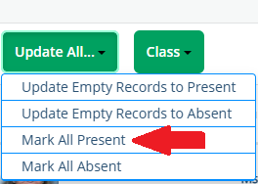
3) For absentees, click their radio button twice to change to a minus symbol.

Verification
⚠️ DON’T PANIC!
There is no confirmation message or save button—your selections are saved automatically.
To confirm:
- Log out and back in
- Return to Attendance Reporting for the same course/date
  - Check for:
    - Green checkmarks (present)
    - Red minus symbols (absent)

Important Reminders
- Do NOT record attendance for students who have withdrawn.
- Ignore these features:
  - Class button
  - Reporting hours attended
  - Excused Absence – will still mark the student as absent and they will be removed from the course.

